Chapter 19, Problem 4.

Using Fig. 19.68, design a problem to help other students to better understand how to determine z parameters from an electrical circuit.
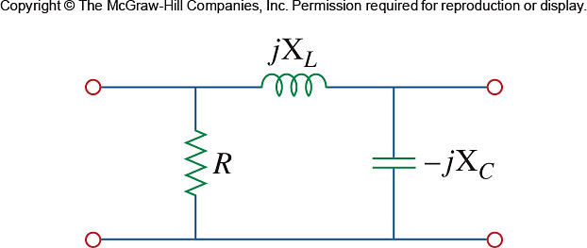

Figure 19.68
For Prob. 19.4.

